**Signals Project**

**Report**

**T-19**

Zeyad Tarek // 52-7231

Zeyad Sultan // 52-4345

**First of all, we imported the following libraries:**

* sounddevice
* numpy
* matplotlib

**Then, we set the time to a 3 second interval initiated from 0 and 12*1024 samples. Moreover, we created the following arrays:**

* **L:** the array containing the frequencies from the 3rd octave to be put in the song.
* **R:** the array containing the frequencies from the 4th octave to be put in the song.
* **ti:** the array containing the initial time value where the corresponding frequency [i] starts.
* **Ti:** the array containing the ending time value where the same frequency [i] ends.

**Then, we defined a function called music(k) and inititated a variable x=0**

To be both used in the loop which adds all the signals together to x.

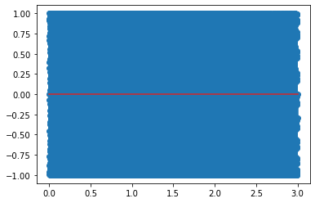**To end with, we plot the graph of x-k, and process the sound.**

